ICT285 Assignment2

23 July 2021

LEE jihu (34061648)

**1**.

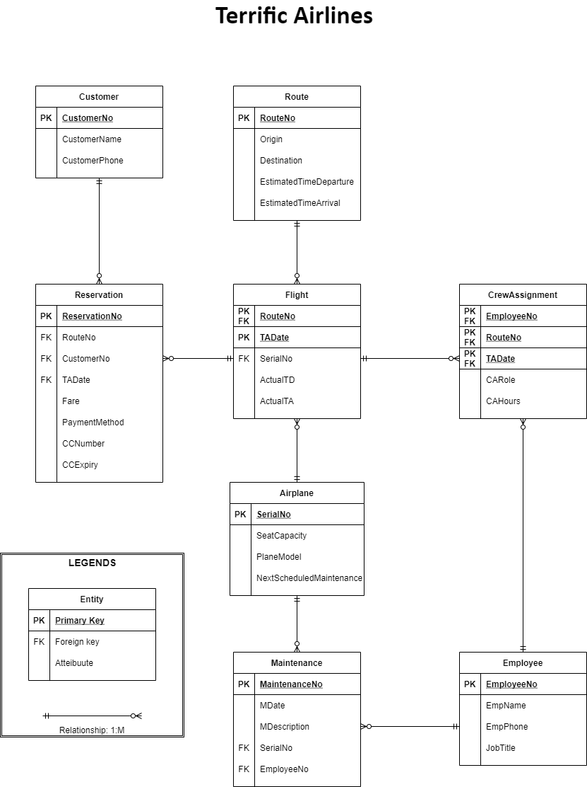

**2.**

In ERD submitted in assignment1, there was several problems. First, no separate entity was required for flight crew. A crew allocation entity is needed to record the many-to-many relationships between crew and employee. And ne employee can be assigned to multiple flights, and many can be assigned to one flight. also, some Foreign keys are misplaced.

Compared to the ERD submitted in Task 1, the above ERD have been improved. First, the entity which had the same meaning, Flight crew and employee has been unified. Instead, it has Crew assignment entity which take cares some of the flight crew’s attribute. And the attribute names are also changed as the relationship between the entity was adjusted and the primary key and foreign key were appropriately allocated accordingly. Finally, a payment entity was also added as an attribute to the reservation entity.

**3.**

**Flight**

|  |  |  |  |  |  |  |
| --- | --- | --- | --- | --- | --- | --- |
| **Attribute name** | **Description** | **Required** | **Allowable values** | **Unique** | **key** | **Oracle data type/size** |
| RouteNo | Unique identifier | Yes | Any valid route number including letter | Yes | PK, FK | Varchar(6) |
| TADate | Terrific Airline Date information of flight | Yes | Any valid date in the format of DD/MM/YYYY | No | PK | Date |
| SerialNo | Unique identifier | Yes | Any valid serial number including letters | Yes | FK | Varchar(6) |
| ActualTD | Actual time of departure | No | 4-digit number (two for hours and two for minutes) | No | N/A | Number(4) |
| ActualTA | Actual time of arrival | No | 4-digit number (two for hours and two for minutes) | No | N/A | Number(4) |

**Route**

|  |  |  |  |  |  |  |
| --- | --- | --- | --- | --- | --- | --- |
| **Attribute name** | **Description** | **Required** | **Allowable values** | **Unique** | **key** | **Oracle data type/size** |
| RouteNo | Unique identifier | Yes | Any valid route number including letter | Yes | PK | (Varchar6) |
| Origin | Departing location data | Yes | Any valid location | No | N/A | Varchar(50) |
| Destination | Destination location data | Yes | Any valid location | No | N/A | Varchar(50) |
| EstimatedTimeDeparture | Estimated time of departure | Yes | 4-digit number (two for hours and two for minutes) | No | N/A | Number(4) |
| EstimatedTimeArrival | Estimated time of arrival | Yes | 4-digit number (two for hours and two for minutes) | No | N/A | Number(4) |

**Reservation**

|  |  |  |  |  |  |  |
| --- | --- | --- | --- | --- | --- | --- |
| **Attribute name** | **Description** | **Required** | **Allowable values** | **Unique** | **key** | **Oracle data type/size** |
| ReservationNo | Unique identifier | Yes | Any valid reservation number | Yes | PK, FK | Number(8) |
| RouteNo | Unique identifier | Yes | Any valid route number | Yes | FK | Varchar(6) |
| CustomerNo | Unique identifier | Yes | Any valid customer number | Yes | FK | Number(8) |
| TADate | Terrific airline Date information of flight | Yes | Any valid date in the format of DD/MM/YYYY | No | FK | Date |
| Fare | Actual price | Yes | Any valid price bigger or equals to zero. | No | N/A | Number(30) |
| PaymentMethod | Method of payment | Yes | Must be one of the selections (cash, card, paypal, etc) | No | N/A | Varchar(10) |
| CCNumber | Card information which is needed to pay | Yes | Any valid number in the format of AAAA-BBBB-CCCC-DDDD | Yes | N/A | Number(6) |
| CCExpiry | Expiry date of the card | Yes | Any valid date in the format of MM/YY | No | N/A | Date |

Customer

|  |  |  |  |  |  |  |
| --- | --- | --- | --- | --- | --- | --- |
| Attribute name | Description | Required | Allowable values | Unique | Key | Oracle data type/size |
| CustomerNo | Unique identifier | Yes | Any valid customer number | Yes | PK | Number(8) |
| CustomerName | Name of the customer | Yes | Any valid name | No | N/A | Varchar(50) |
| CustomerPhone | Phone number of the customer | Yes | Any valid phone number | Yes | N/A | Number(8) |

**Airplane**

|  |  |  |  |  |  |  |
| --- | --- | --- | --- | --- | --- | --- |
| **Attribute name** | **Description** | **Required** | **Allowable values** | **Unique** | **key** | **Oracle data type/size** |
| SerialNo | Unique identifier | Yes | Any valid serial number including letters | Yes | PK | Varchar(6) |
| SeatCapacity | Capacity of the airplane | Yes | Any valid number less or equals to full number of seats | No | N/A | Number(3) |
| PlaneModel | Model name | Yes | Any valid model name | No | N/A | Varchar(20) |
| NextScheduledMaintenance | Schedule data of the next maintenance | No | Any valid date in the format of DD/MM/YYYY | No | N/A | Date |

**Maintenance**

|  |  |  |  |  |  |  |
| --- | --- | --- | --- | --- | --- | --- |
| **Attribute name** | **Description** | **Required** | **Allowable values** | **Unique** | **key** | **Oracle data type/size** |
| MaintenanceNo | Unique identifier | Yes | Any valid maintenance number | Yes | PK | Number(10) |
| MDate | Maintenance date data | Yes | Any valid date in the format of DD/MM/YYYY | No | N/A | Date |
| MDescription | Description of maintenance contents | No | Any valid description | No | N/A | Varchar(500) |
| SerialNo | Unique identifier | Yes | Any valid serial number including letters | Yes | FK | Varchar(6) |
| EmployeeNo | Unique identifier | Yes | Any valid employee number | Yes | FK | Number(5) |

**Employee**

|  |  |  |  |  |  |  |
| --- | --- | --- | --- | --- | --- | --- |
| **Attribute name** | **Description** | **Required** | **Allowable values** | **Unique** | **key** | **Oracle data type/size** |
| EmployeeNo | Unique identifier | Yes | Any valid employee number | Yes | PK | Number(5) |
| EmpName | Name of employee | Yes | Any valid name | No | N/A | Varchar(50) |
| EmpPhone | Phone number of employee | Yes | Any valid phone number | No | N/A | Number(8) |
| JobTitle | Specific Job title of employee | Yes | Any valid job title | No | N/A | Varchar(25) |

**CrewAssignment**

|  |  |  |  |  |  |  |
| --- | --- | --- | --- | --- | --- | --- |
| **Attribute name** | **Description** | **Required** | **Allowable values** | **Unique** | **key** | **Oracle data type/size** |
| EmployeeNo | Unique identifier | Yes | Any valid employee number | Yes | PK, FK | Number(5) |
| RouteNo | Unique identifier | Yes | Any valid route number including letter | Yes | PK, FK | Varchar(6) |
| TADate | Terrific Airline Date information of flight | Yes | Any valid date in the format of DD/MM/YYYY | No | PK, FK | Date |
| CARole | Role that employee did during the flight | No | Any valid role | No | N/A | Varchar(50) |
| CAHours | Time data of the flight (worked time) | No | Any valid 2-digit number | No | N/A | Number(2) |

**4.**

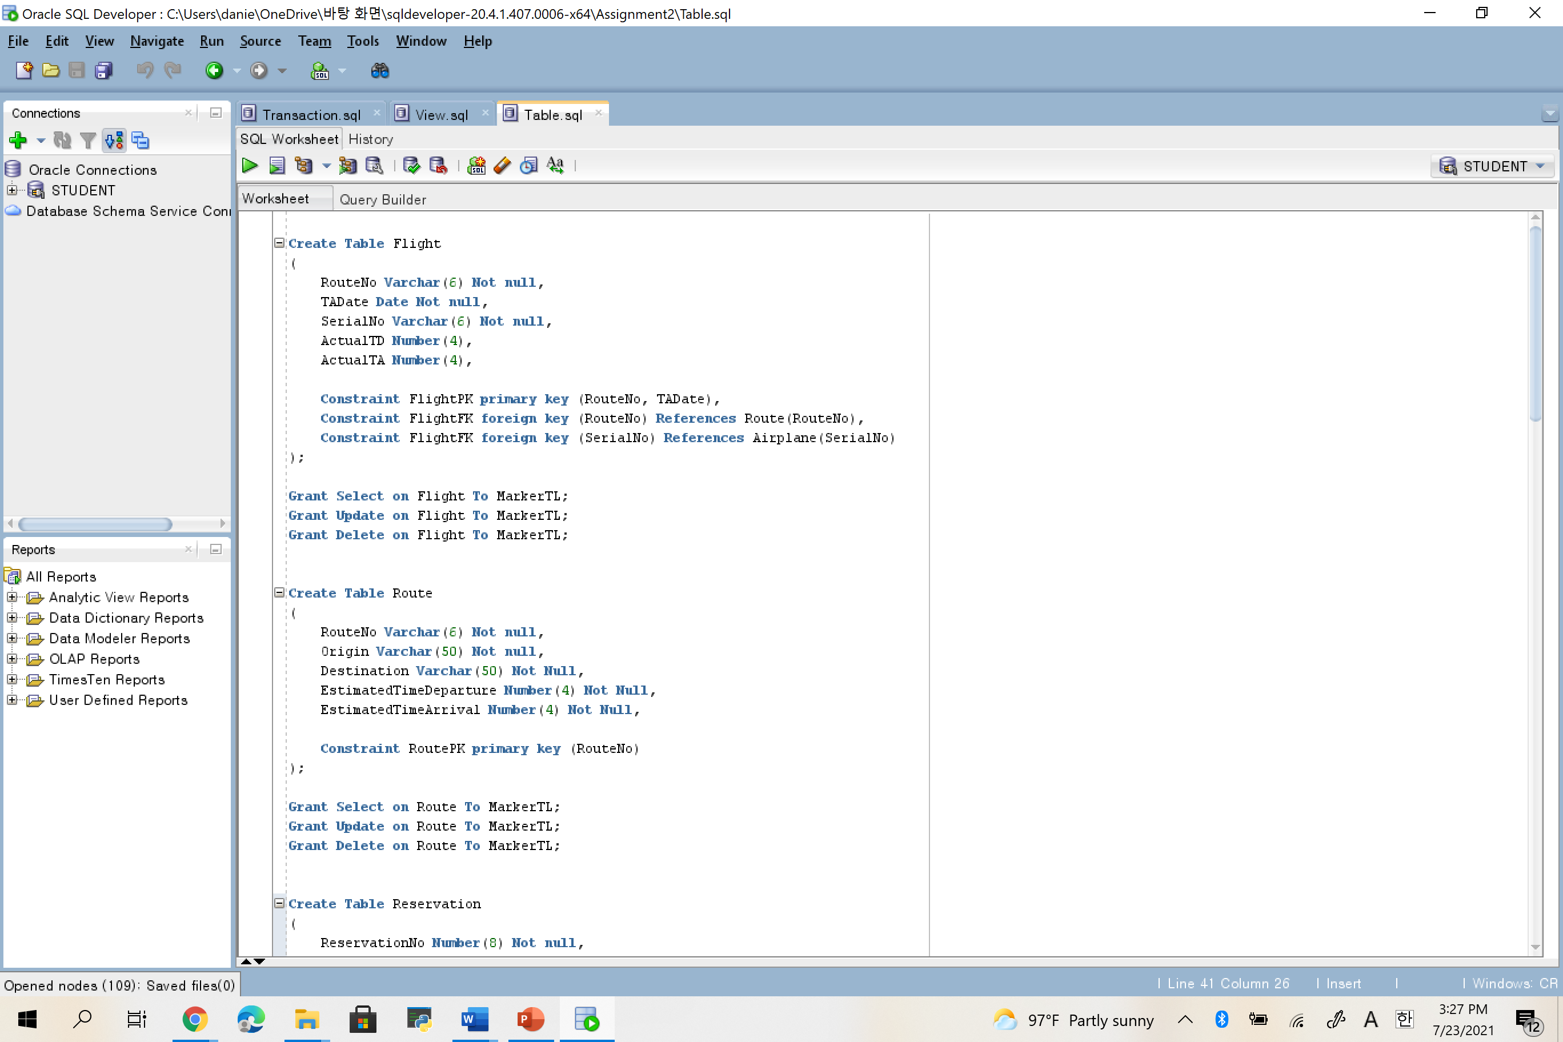

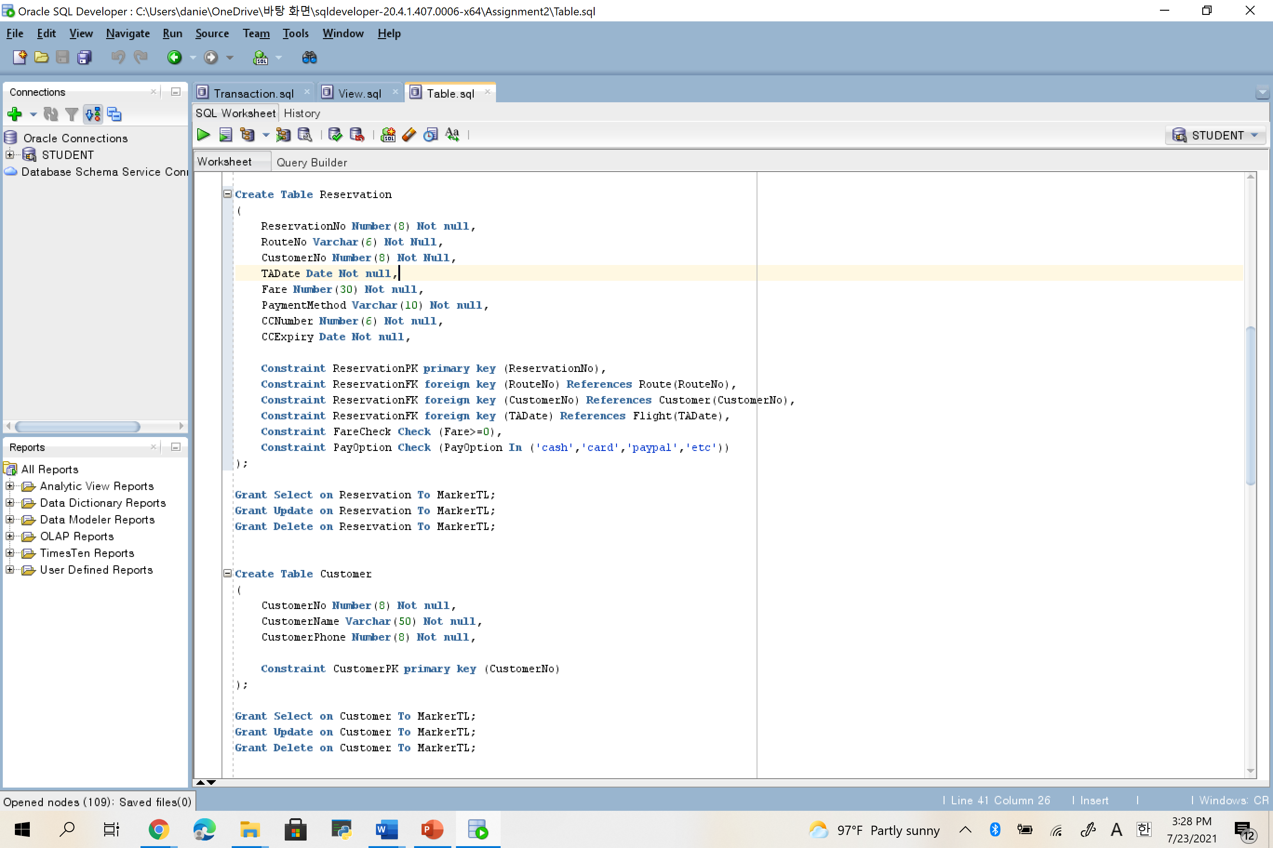

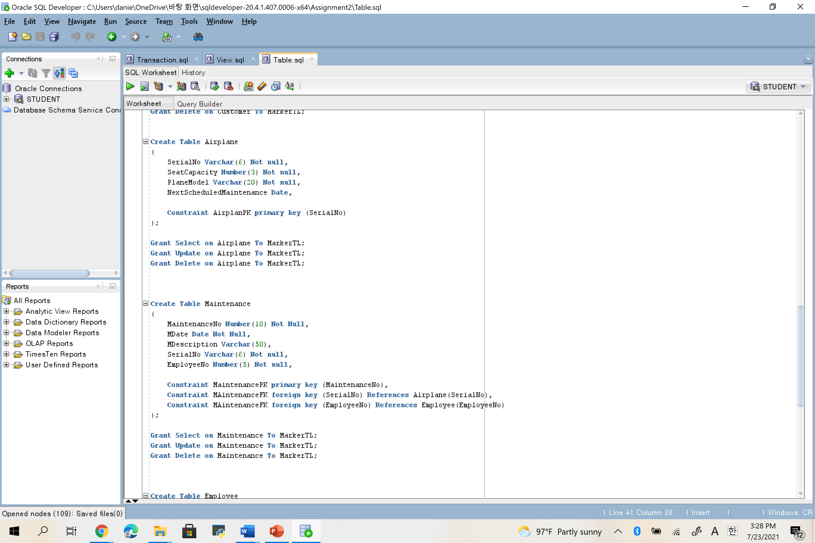

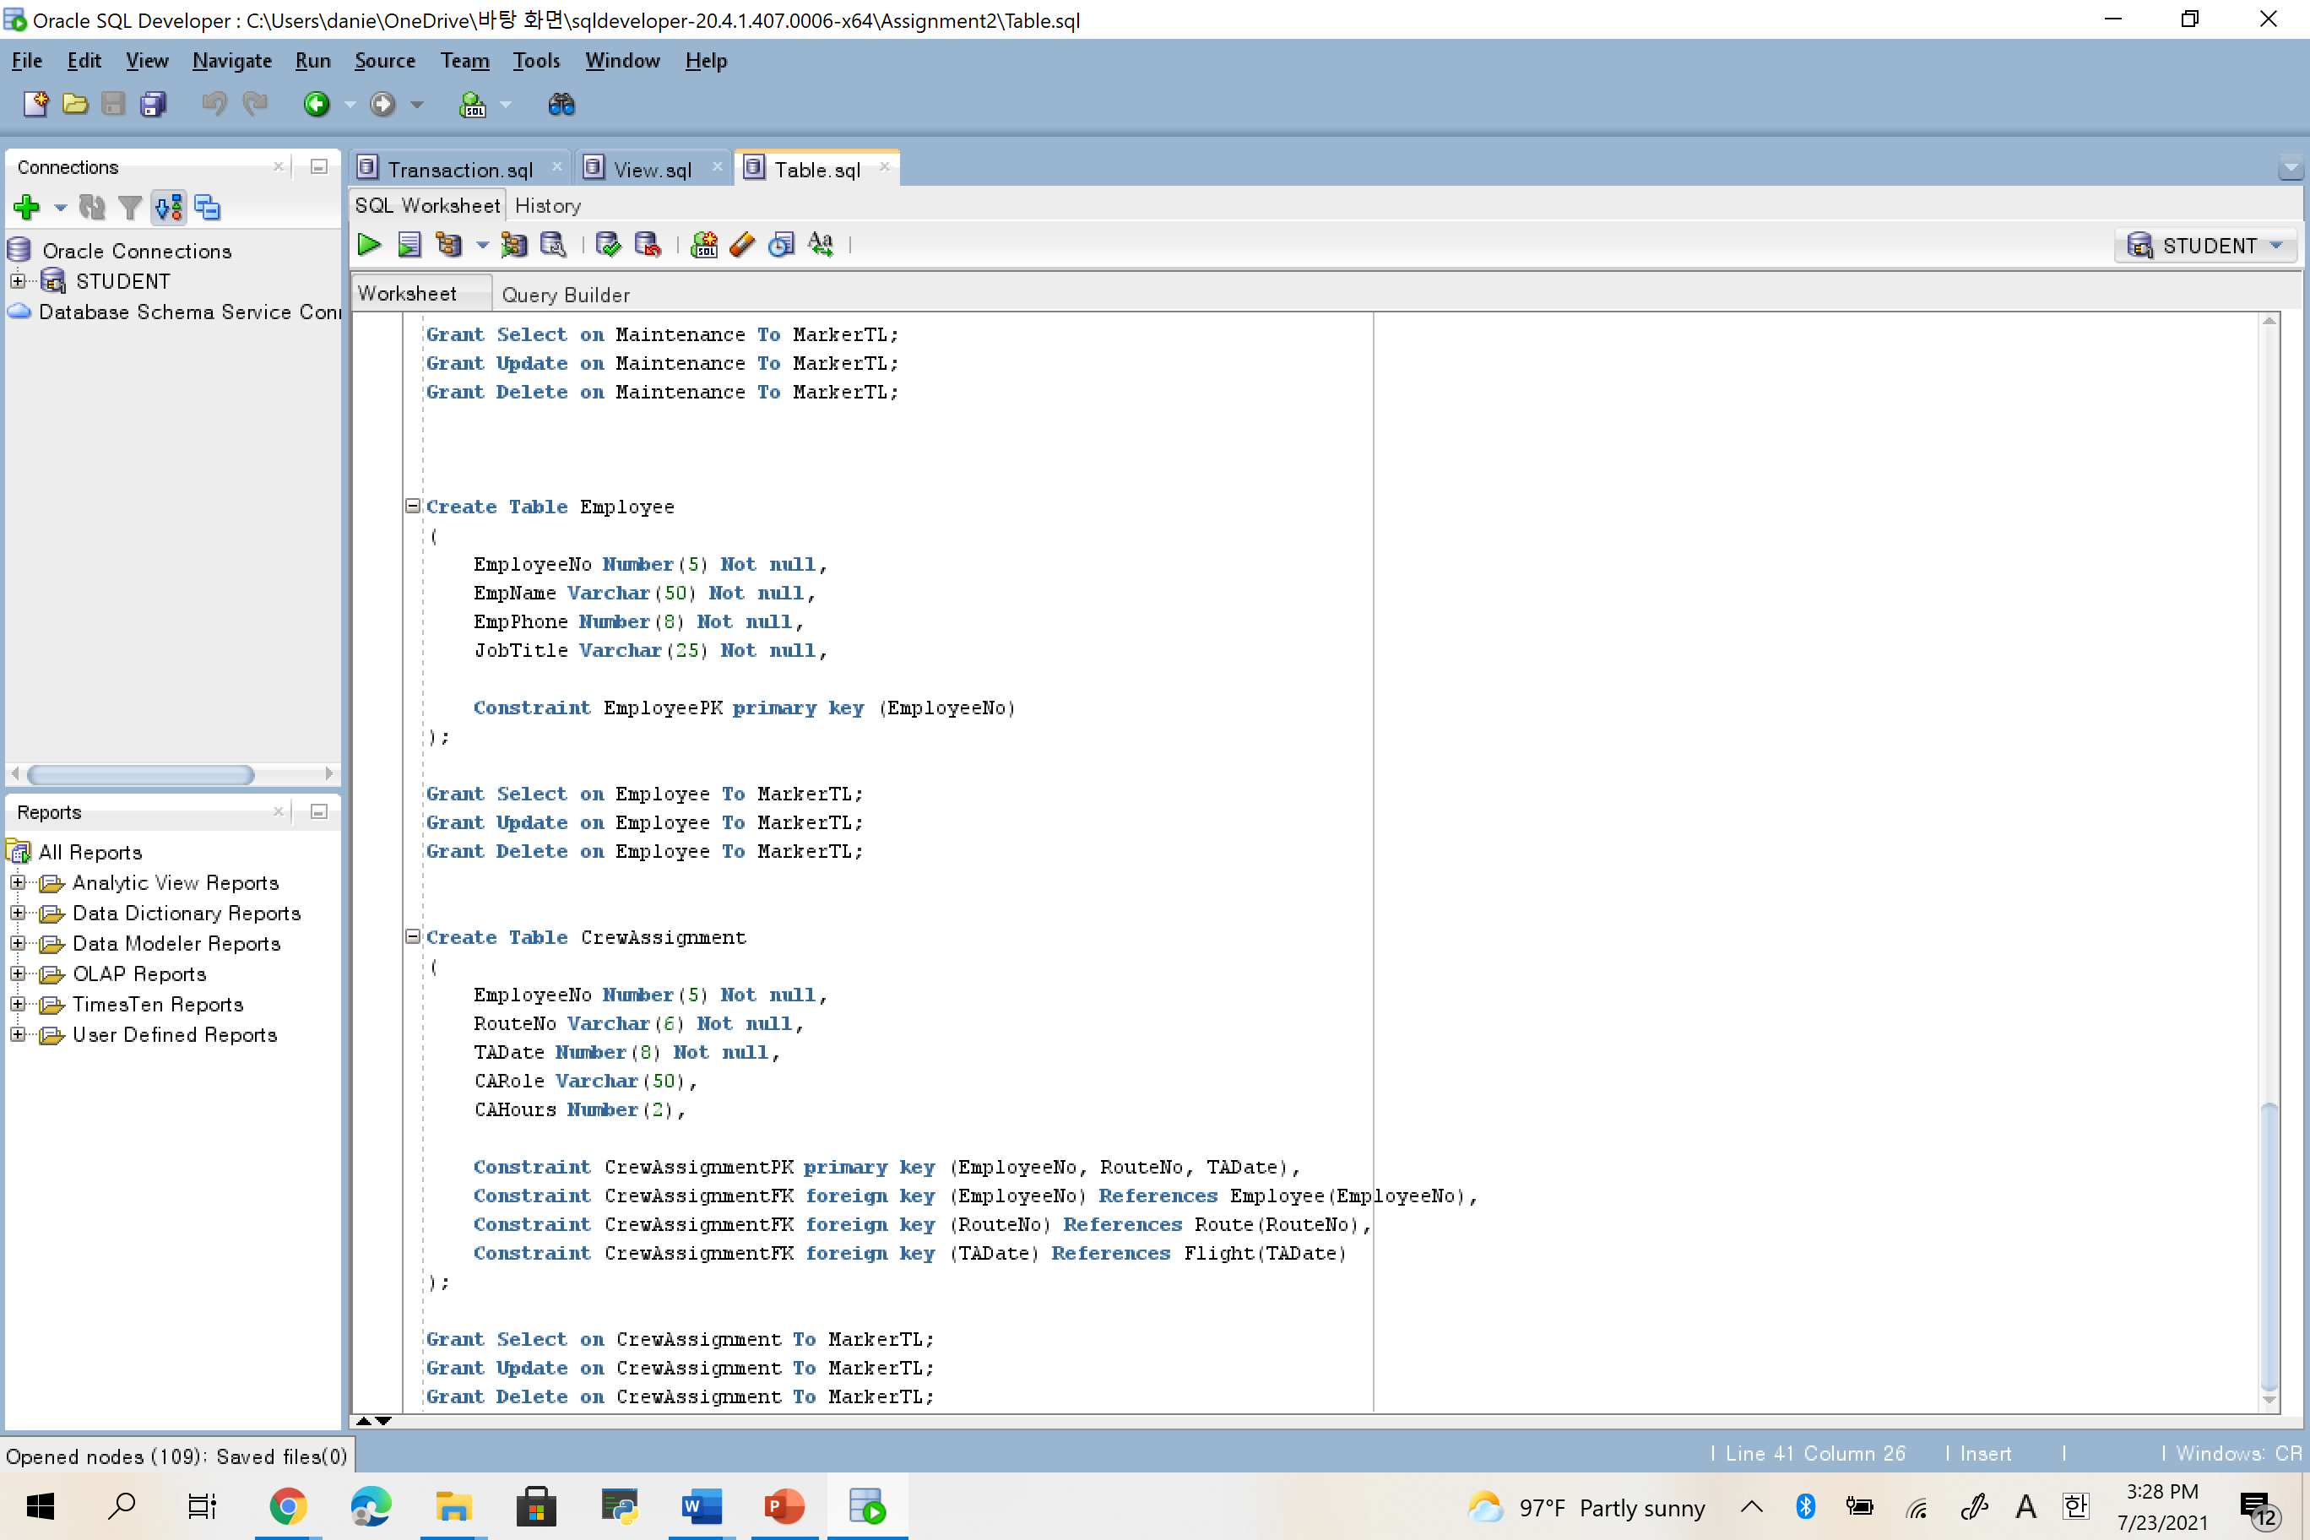

**5.**

**Transaction1**

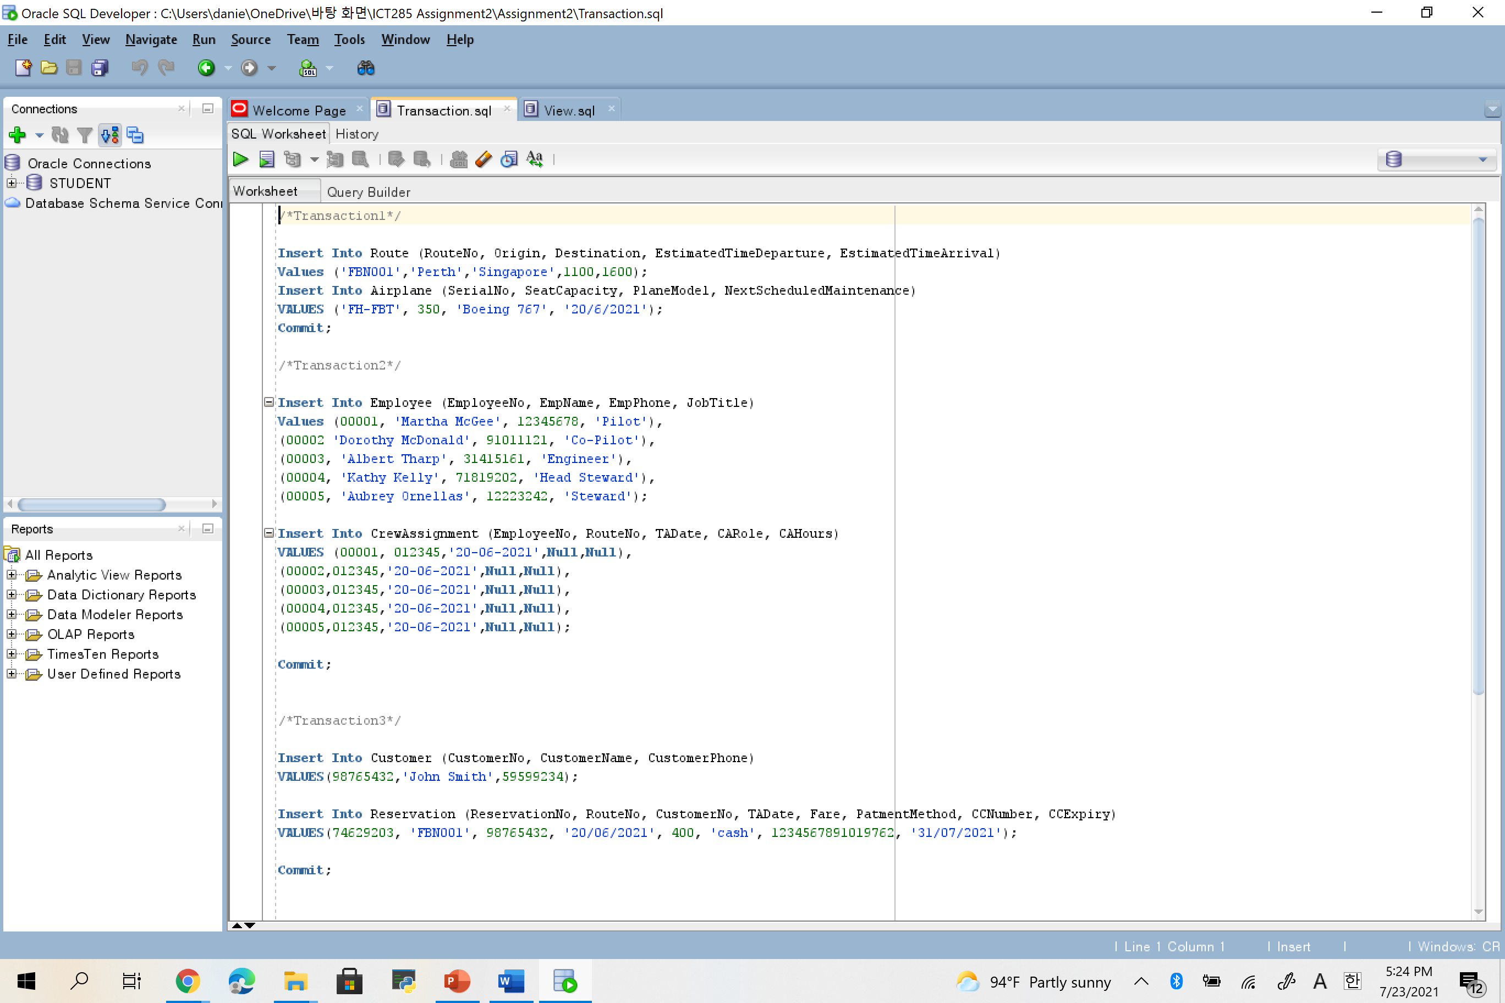

**Transaction2**



**Transaction3**



**Transaction4**

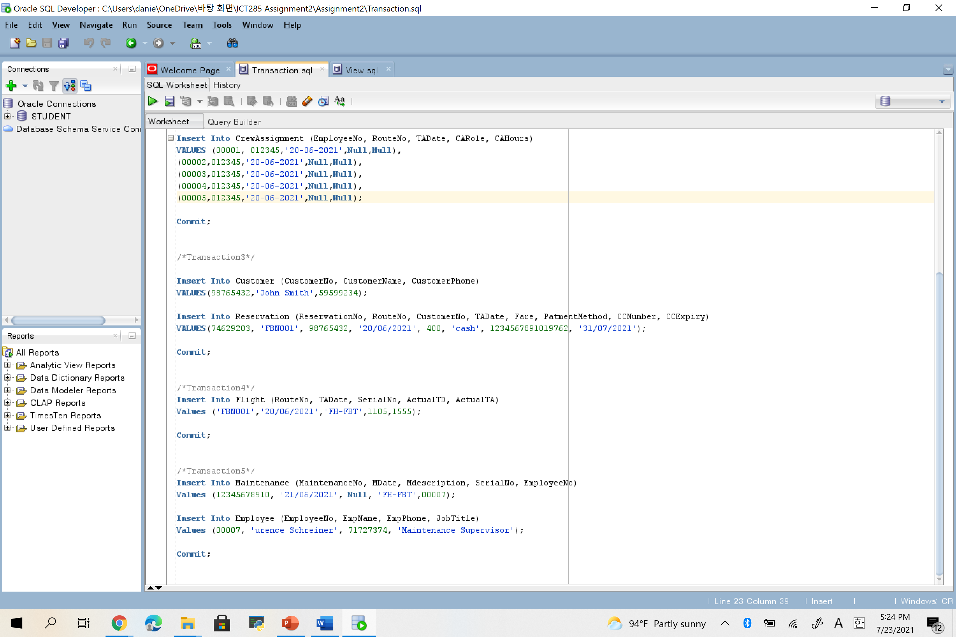

**Transaction5**



**6.**

**ViewA**

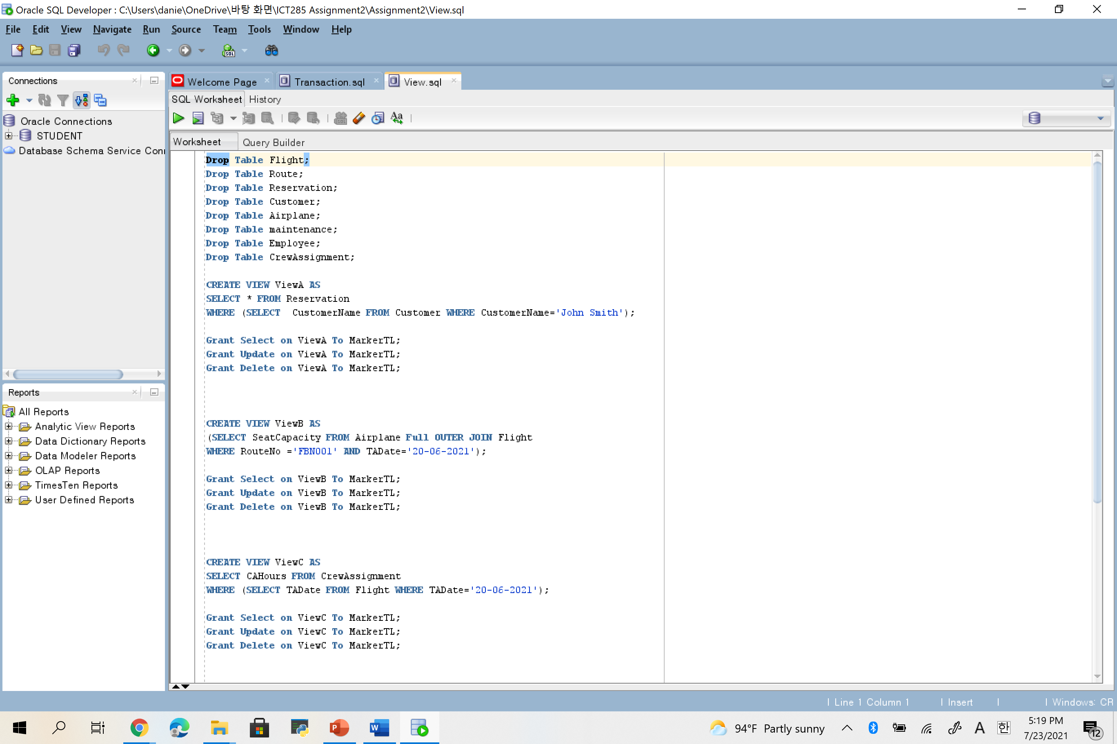

**ViewB**



**ViewC**



**ViewD**

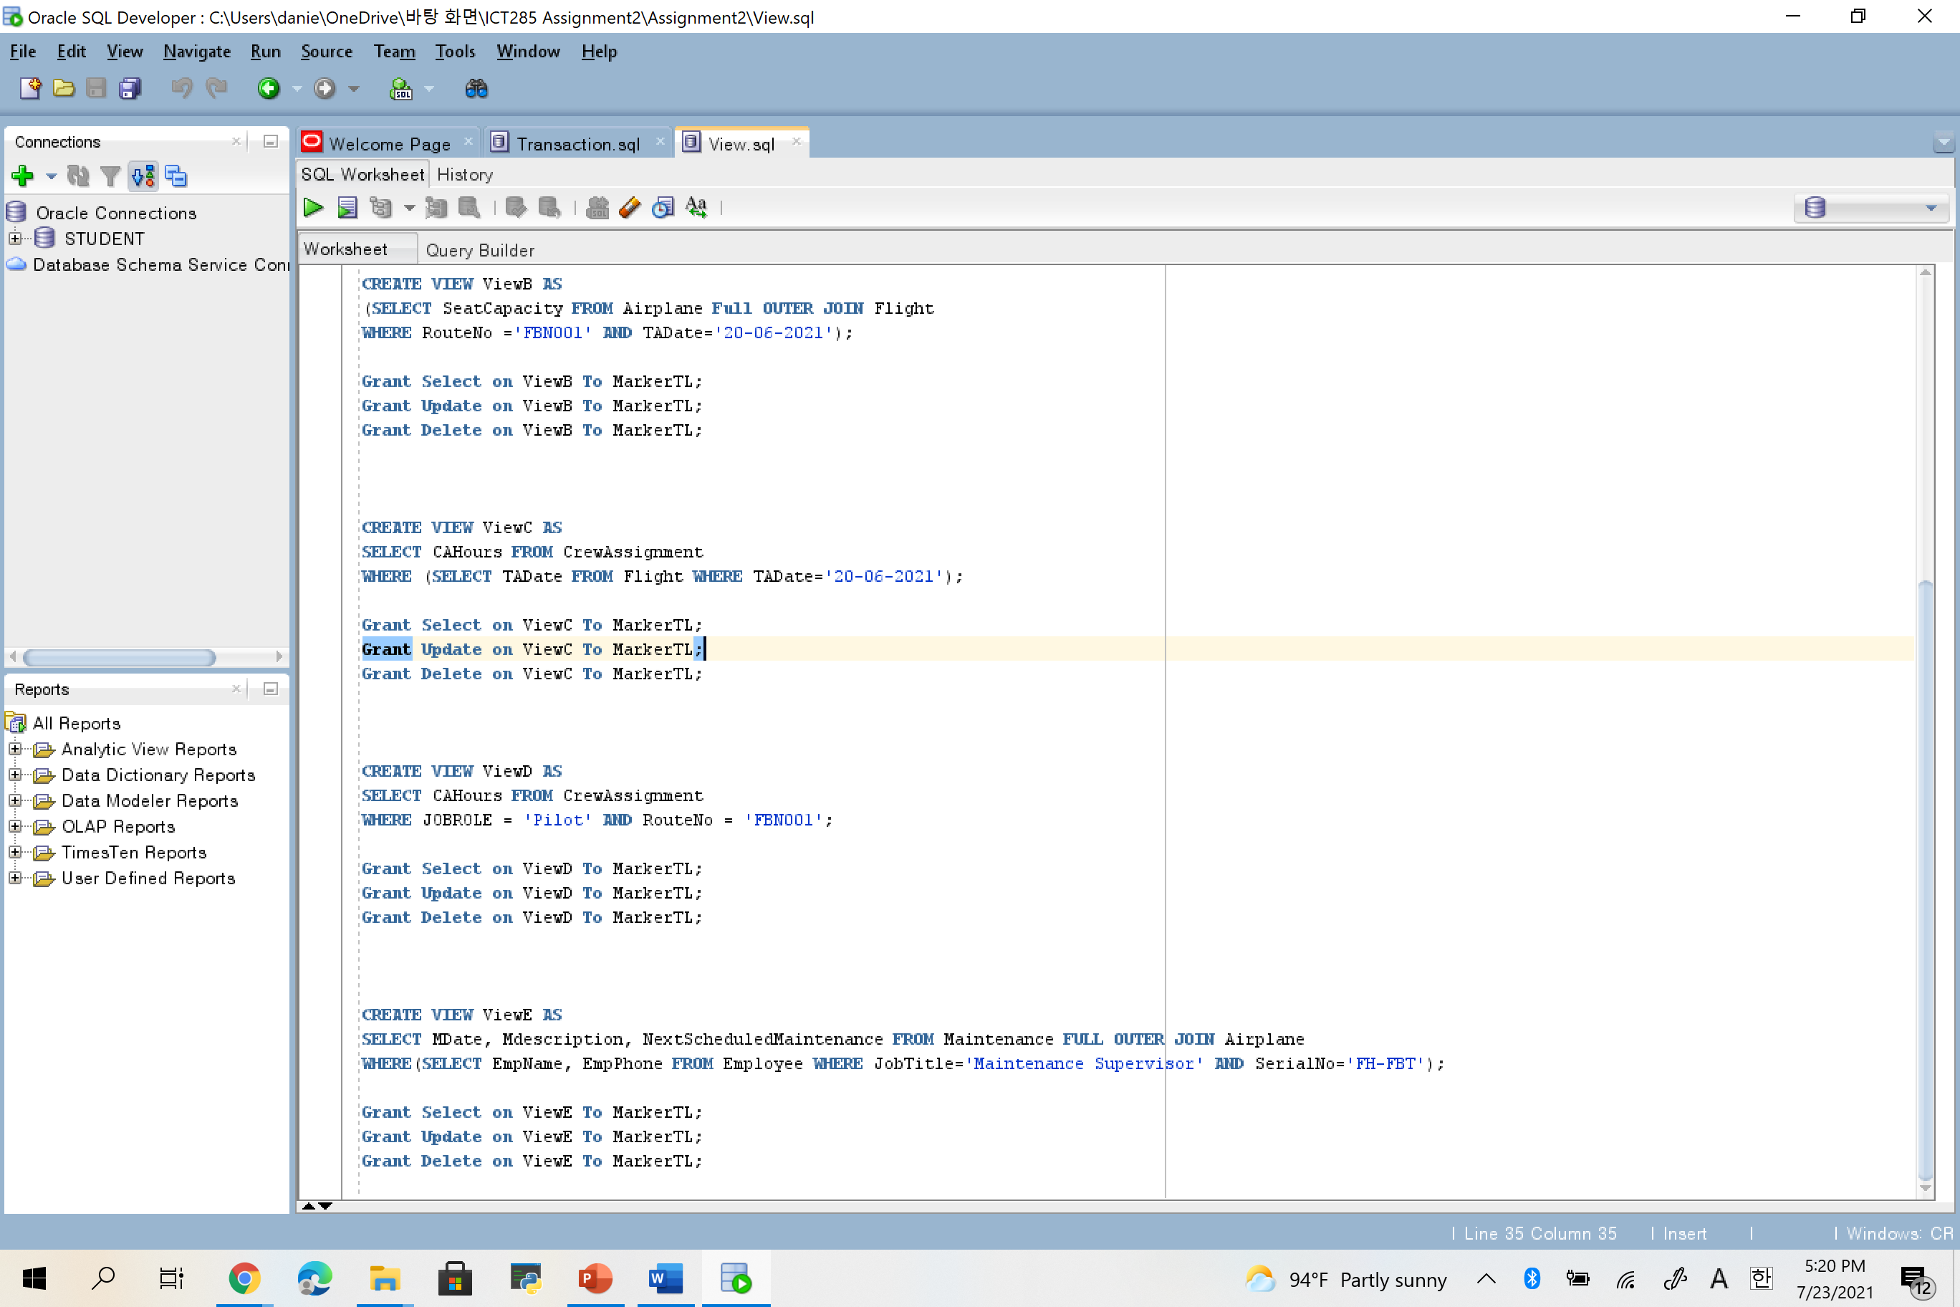

**ViewE**